The implications of Artificial Intelligence in SLA

Introduction

Second Language Acquisition (SLA) has been with us from pretty much the beginning of spoken language itself. As different languages have developed independently there’s always been a strong motivation to be able to communicate our needs and desires with each other. And somehow we’ve always found a way to do so.

Students in ancient times (the 1–2% of the population that received a formal education) trained in SLA through tutors, using a strict translation method—e.g., Assyrian or Akkadian to Sumerian¹. Everyone else—traders, migrants, people living in border communities, etc. picked up foreign languages through a communicative method, fueled predominantly through instrumental motivation born of concerns, such as putting food on the table, finding work, making friends, and seeking shelter. Their methods worked then, as they do now, through the twin engines of motivation and comprehensible input.

Orientation and SLA
When Cortez began his “New World” conquests he communicated with indigenous peoples through Jerónimo de Aguilar, a Spaniard who had spent 7 years living with a Mayan tribe, after being shipwrecked off the coast of Mexico, during which time he learned the Mayan language. Cortez later acquired Doña Marina as a tribute from a defeated Mayan tribe. Born of Aztec nobility, she was fluent in Náhuatl, becoming fluent in Mayan, as well, after being sold to Mayan traders as a girl. Doña Marina was able to quickly learned Spanish while living as a captive of Cortez’ army, giving him the ability to communicate with all major indigenous peoples throughout the region.

This type of instrumental orientation (need-based acquisition) has been the prime motivating factor for most SLA learners throughout history. Only recently has Language been studied out of curiosity or cultural interest. But even in this realm, we know that a strong desire (integrative orientation) to understand and interact with other cultures through language is also critical driver of SLA (DuLay & Burt (1977), Krashen (1981, 1982), Ellis (2005), et. al).

Both instrumental and integrative orientations have been shown to create an interest in and openness to SLA that drives the best results. And history conclusively shows us that a proper orientation (instrumental or integrative) combined with enough lexically varied comprehensible input (and perhaps output too) in a communication-focused environment, has produced a steady stream of successful L2 learners year after year for 1000s of years. SLA has already been a long-running success story for those who needed it or who were open to it and, additionally, had the good fortune to live in a place where their L2 was easily available.

Today, hundreds of millions study second languages yet fail to achieve proficiency. Our paper deals with two reasons for this—lack of comprehensible input, and difficulty in maintaining high motivation and engagement over the long haul. We believe that AI can play a profound role in delivering both of these catalysts to SLA. This paper will explore current pedagogical considerations revolving around these specific issues and examine how “AI” can be implemented to best address each one.

How my personal experiences have influenced my views on SLA

I worked for a number of years as an attorney in Miami, Florida with Spanish-speaking clients through an interpreter. After about a year and a half, with no other training, reading, grammar exercises, etc., I found that I was able to communicate directly with my clients in Spanish 70–80% of the time. I’ve retained that ability to this day.

In my case there was a genuine openness to and interest in learning Spanish. Miami is a majority bi-lingual community (84% of its residents are of Hispanic origin). I also believed that speaking directly to my clients was a more efficient use of my time and created a better attorney-client relationship. Lastly, I received a constant flow of varied, comprehensible real-life L2 on a daily basis in a low stress environment.

In considering how AI might be used to facilitate SLA, I have leaned heavily on the model that worked for me, with the understanding that learners are anything but homogeneous. In considering the ideal pedagogical model, I have used Ellis’ “Instructed Second Language” (2005) as a road map.

Ellis’ approach is inclusive of several various competing theories, and his bias towards an input-based task-oriented approaches leveraging interaction, effective collaboration, and resultant attention to form lend themselves to a clear role for a new technologies, generally (CALL, MMPORG, etc.) and AI in particular.

Recent SLA technologies

CALL
A variety of CALL technologies have been applied over the past 30 years, and have been shown to have a proven track record of improving performance in certain areas. For example, CALL programs, which provide glossing in L1 reading tasks have been demonstrated to improve both vocabulary and reading comprehension (Taylor, 2009). CALL glosses have been shown to be more effective than non-CALL (print) glosses (Abraham, 2008). These cites are part of a larger study of CALL review articles by Plonsky and Ziegler (2016), which cites various other review-based studies demonstrating positive effect sizes, globally and for a variety of specific issues.

ICALL
ICALL or “Intelligent” CALL includes a range of technologies, which not only deliver online teaching modalities—they can interact with students in a variety of ways. For example they can identify input errors and provide opportunities for correction (Heift, 2002); (Nagata, 1993) and examine student proficiency on a variety of tasks. They can also display unique results-based content, including a variety of simulated “conversational” interactions with and guidance for students (Jia, 2009).

CMC
CMC technology has allowed teachers to provide greater focus on speaking proficiency, by being able to deliver far more comprehensible input, and facilitate much greater student interaction with tutors or other students than is possible in a classroom, where speaking time per student is quite limited. As pointed out below:

“Videoconferencing gives students an alternative to the type of speaking practice that is assumed to occur solely in the classroom. In actual fact, small group videoconferencing—for example, one instructor working with two or three students—can often evoke a more intensive speaking experience than sitting in class and responding only two or three times in an hour, which is the norm in most language classrooms.” (Blake, 2016).

Game-based and MALL
The use of Games, whether off-the-shelf (COTS) or “Serious” games desired for learning and MALL (Mobile Assisted Language Learning) for SLA has become increasingly popular during the past 10 years, especially since the advent of smart phones. Learners clearly gravitate towards games and game-like simulations and environments, because they offer high engagement and potential rewards. Thus, there is a powerful instrumental motivation for learners to understand the various messages, instructions, and textual content displayed during each game session, as it has direct impact on the outcome.

Various studies have provided evidence that Game-based and MALL learning improves outcomes in a variety of SLA areas (Suh, Kim, Kim, 2010). Meta-studies have also delved into differences in performance based on game type (“Serious” games vs, MMPORG, COTS, etc.), Yudintseva (2015), and, examined MALL, exclusively, Burston (2015).

Reinders (2016) looked at how gamers process and use instructions in a 2nd language and how this affects the brain and comprehension. He points out that the areas of the brain involved with gaming and SLA have considerable overlap. This is hardly surprising in that communication is an important aspect of both sets of behavior. What’s interesting is that there may be opportunities to provide content that stimulates an area of the brain (through gaming) that also opens the participant up for SLA by providing the lowest possible affective filter.

A few specific applications
I-Fleg, a virtual game (Amoia, 2008), housed within Second Life isn’t so much a game as it is an interactive experience. The user enters a 3D projection of a house and moves around inside, examining various objects inside. There’s a plot of sorts, in which users search for specified objects, but, the point of the game is to have users identify visual objects with French words or phrases and to use those words correctly in a sentence.

The game database keeps records of user proficiency and displays different content based on level. This type of game-ification and realistic depictions of and searches for objects may be effective in creating high engagement through virtual discovery experiences.

TLCT
Tactical Language and Culture Training Systems was developed by Johnson & Valenti (2009) for the US Armed Forces to teach military personnel how to interact and communicate with local tribesman in Iraq and other places. The subject matter is relevant to immediate need and possibly to their survival or the survival of others. The need to understand cultural nuance as well as specific verbal instructions, responses, terms, greetings, etc. is tied to specific visual situations in the game.

The game uses voice recognition software, adding a speaking dimension to the simulation. The goal is to create conditions that are as real as possible and make accurate assessment and interaction in each situation a necessity. Under such conditions, the player is highly focused on making the correct responses and pronouncing words correctly, in the right tone, and correct sequence.

An AI Primer

In 1950 Alan Turing postulated a test to determine the criteria for a truly “intelligent” computer. The “Turing Test”, as it came to be known, requires that the natural language responses from a smart machine and a human being be indistinguishable, in response to queries put to each by a third party.

The very first widely publicized instance of a computer program “passing” the Turing Test , albeit in a limited set of circumstances, was the “ELIZA” “Doctor” program, written by Joseph Weizenbaum. The program used Rogerian Psychotherapy interviewing protocols and offered them up in response to queries by simulated first-time patients. ELIZA’s ability to generate appropriate “open ended” responses to these queries could easily give “patients” the impression they were being interviewed by another human being. We’ll come back to ELIZA.

AI has evolved along many parallel and sometimes diverging tracks. Let’s take a look at a few; then we’ll take a deep dive into Smart Chat, a product designed to develop SLA through AI-enhanced chat.

Game/Interactive AI
One branch of AI has focused on game theory and has used machine learning, on a massive scale to analyze and improve outcomes for games requiring player moves. This is epitomized by the victory of Big Blue, the IBM chess playing program that beat Kasparov, and, more recently, Google’s “Alpha Go’s” victory over the reigning human “Go” champion.

A slice of these technologies are used today in online and mobile gaming and in other AI-fueled applications, which examines user data and behavior and expected future behavior to adjust position, content or environment. “Game” AI in video or first person shooter games involves some analysis of player and non-player character (NPC) position, actions, and skill level, in order to move its characters in the most efficient way, and to target players, focus and shoot its weapons, or to communicate with players.

Games have become progressively more sophisticated in responding to specific user behaviors. This is a potentially fertile field for SLA, because these games deliver highly engaged and motivated users with a need to understand the game’s messaging to play well.

Big Data
Another branch of AI has focused on analyzing detectable visual, environmental, and behavioral events and looked for actionable patterns within vast arrays of data—for example, world events that cause financial markets to move in certain ways. Examples of Big Data may be found in trading programs used on Wall Street and in applications such as “Banjo”, which analyzes and attempts to make sense of unusual movement within a grid of publicly accessible video cameras covering large swaths of populated areas on the globe. For example, Banjo became aware of the events, which became known as the “San Bernadino Attack” within a few minutes after it began, and was able to transmit the first confirmation of the event to news media within 46 seconds of first becoming aware of it.

Big Data can help to uncover commonalities in the structure and usage of various language corpuses and in the use of specific words, phrases, lexical structures, etc. For example, it might be useful in developing a conversational model covering the normative distribution of social media chat by high school students, in order to provide them with an immersive L2 social chat experience. Big Data may become far more relevant as instant translation comes online or as bots develop greater semantic proficiency.

NLP
Natural Language Processing (NLP) applies a complex set of rules for contextualizing, sequencing, assigning meaning, and weighting to lexical input. In providing a machine with data sets in the form of sentences the goal is to produce appropriate human-like output. These data sets are generally obtained through

To do that, the machine is trained to parse and organize lexical data. It first, typically, examines individual lexical entities for, within the sentence and then performs a syntactic analysis, in which words are parsed and extracted. The syntactical relationships are produced first in a context-free grammar, and rules are developed for creating potential syntactical structures. Semantic and sentiment analyses are also performed.

The goal of this training is to be able to provide an appropriate response for any particular sentence, so long as it has trained on this material. So, when “How are you feeling today” the machine should be able to respond with something like “I am feeling OK”.

Chat Bots
Let’s take another deeper look at ELIZA. How did it work?

Eliza was basically a list search function that identified keyword patterns in user-generated content, and activated canned responses. For generic queries containing known keywords, it could provide “intelligent” responses. If the patient typed “I feel despondent” the system searched for specific key words such as “feel” and “despondent”, flipped “I” around to “you” and used a generic template such “When did you first (feel despondent)” to respond. ELIZA never understood content—it identified and responded to it in predetermined ways.

Over the past 20 years or so, NLP has vastly improved the ability of computers to parse and analyze lexical content, and to provide syntactically and, in many cases, semantically appropriate responses. Still, they don’t really “think”, in terms of having conceptual knowledge to draw on—they train for months on a specific corpus of text, examining word sequence, grammatical function, and meaning, attempting to provide responses that make sense and are useful to the questioner. Furthermore, they can only parse unambiguous un-nuanced input that sticks mainly to primary meanings.

This causes errors. “I had a piece of pie” might be analyzed as referring to prior possession of the pie, based on the primary meaning of “had” whereas real world experience tells us otherwise. Even if the computer is able to parse this phrase correctly due to building in a bias towards consumption where food is involved, “John had a piece of pie with him” and “John had a piece of pie with milk” would still be extremely difficult to parse.

One can imagine creation of many sets of rules to deal with each such case, but this would present the same kinds of problems in trying to approximate the full set of grammar rules for English. Humans simply know and understand things related to meaning that are difficult or impossible to fully describe, and this difficulty prevents NLP from getting beyond a fairly rudimentary level of understanding.

One of the more interesting recent L2 chat bot projects has been “Chat Bot Lucy” (Jia, 2009). Lucy is specifically designed to engage in both general chat, within certain parameters and guided chat. The guided chat system initiates conversations with a human using a branching script. The system then predicts potential human responses to its queries and, responds appropriately when it correctly predicts the response or very close. For example, if Lucy asked “Do you want to order now?” in a restaurant simulation it might look for any 4 or 5 expected responses. Lucy also has a life-like avatar and a human voice, designed to create engagement. Lucy also gives give learners open-ended gap filling quizzes, which promote creative L2 thinking and make grammar and spelling corrections. In classroom tests, students that worked with Lucy showed large effect sizes.

Chat bots, along the lines of Lucy have recently been implemented on several language learning websites, in ways where their inherent weaknesses are avoided. Duolingo.com, for example, for uses bots in specified transactional situations, such as booking a room. We think that bots function best when their interactions with humans are very predictable, and where they can receive sufficient training to respond appropriately to a variety of queries.

Summary
Bots certainly provide comprehensible input and can carry an L2 conversation. However, they don’t provide the experience of having real life conversations with a real people, however, nor do they lead to real bonding. One may ask whether they lower the affective filter such that students process these conversations subconsciously, resulting in SLA. I’m not sure of the answer to that. Bots are excellent at correcting user errors

AI certainly has a useful role to play in gaming, where user attention is clearly focused on enjoying/playing/winning the game, and where content is assimilated specifically for the purpose of acquiring the knowledge needed to play better, understand rules/goals better, etc.

So, we think there’s a threshold question we need to ask in terms of AI’s current and future implications for SLA. What is it capable of doing well now; what can we expect it to do well in the near and distant future, and how to harness the benefits of AI to build the best SLA paradigm right now. As will become clear, we think that there are alternatives to bot chat that leverage some of the same NLP capabilities, but create more coherent and profitable conversations and, simultaneously, developer higher engagement and motivation over the long term.

The nexus of AI and SLA

AI is a powerful technology with the ability to engage an entire generation of new language learners. Its potential for enhancing SLA is huge, but so is its potential for being misused or used inefficiently. Because AI is not a cheap “out-of-the-box” solution, it’s worth taking a look to explore its antecedents, current usage, and hopefully stellar future as an SLA enhancement tool, within the language-learning ecosystem.

How and where to deploy AI
AI can be employed in fully autonomous situations, including games, interactive lessons, or unique exploration activities that customize the experience based on user data or real time user behavior, be it click patterns, text queries, or voice. Looked at in terms of user experience, AI can do all of the following, in response to user information and real time behavior:

Vary the visual, auditory, tactile, etc. experience of the user
Vary game or exercise rules
Vary the content being provided to the user
Provide feedback based on individual user performance
Engage the user in conversation
Facilitate or enhance conversation between multiple users
Help the user to find information, images, or other content

When one considers these capabilities it’s not difficult to envision a whole host of games, social, exploration, and learning activities, and search-related activities designed to enhance SLA that might profitably incorporate AI.

But we should remember that the term “AI” itself implies a kind of intelligence that seems human. Given this ability to “impersonate” human behavior, why not use it to provide the one most precious resource lacking in L2 teacher’s arsenal—the ability to provide extensive, quality L2 interaction, built about implicit learning, within a communicative context, with each and every student, according to his or her capabilities.

This squares well with Ellis’ review article (2004), which notes that:

“Successful FL learners seek out opportunities to experience the language outside class time. Many students are unlikely to make the effort unless teachers (a) make resources available and (b) provide learner-training in how to make effective use of the resources.” (p.___)

AI is one of the growing number of resources that will become increasingly available to L2 learners. AI’s unique ability to provide human-like interaction lends itself to communicative contexts, whether chat or task-based individual or group activities:

“Given that it is implicit knowledge that underlies the ability to communicate fluently and confidently in an L2, it is this type of knowledge that should be the goal of any instructional programme…There is consensus that learners need the opportunity to participate in communicative activity to develop implicit knowledge.” (p. ___)

Fortunately, there are best use cases in which the full power of AI can be brought to bear to facilitate SLA, through a communicative approach that adheres to elicits correct grammatical as well as lexical forms.

AI works best within a communicative approach
The very nature of AI itself—the ability to present itself as a thinking entity to a human, lends itself to a communicative approach. AI’s greatest asset, as it relates to SLA, is its ability to deliver engaging, low-stress, comprehensible conversation or exciting exploratory or gaming experiences conjoined with “mission critical” L2 messaging.

While AI’s ability to configure sentences according to predetermined rules, and to detect non-conforming user input also makes it ideal for explicit grammar-based activities, we believe that a task or chat-based approach that presents correct grammar in a variety of different high-engagement contexts, or presents rules within the context of a high-engagement activity makes the most sense.

Imagine a variation on “I-Fleg”, in which learners receive instructions in French, based on proficiency level, which includes a steady stream of L2 feedback based on user decisions (“You’re getting warm” =“Tu chauffes” + image showing something heating up).

Language Hero’s Smart Chat

Intro and description of Smart Chat
I’m a co-founder of an Ed Tech Company named Language Hero. We’re currently developing an AI-fueled video chat language practice app, which empowers students, who can’t speak each other’s language to have comfortable, comprehensible, varied conversations in it, leading to speaking proficiency.

L2 learners select from pre-translated content, listen to a corresponding audio clip, and repeat it. Their L2 speaking partner corrects pronunciation and chooses/speaks new content. This back and forth process creates a conversation “tree”, with ever branching, comprehensible content, fueling millions of comprehensible conversations in a relaxed environment. Learners may also select sentence blocks and add keywords through image strips and word lists, glossing/reinforcing keyword choices and processing.

Screen Shots from “Smart Chat”:
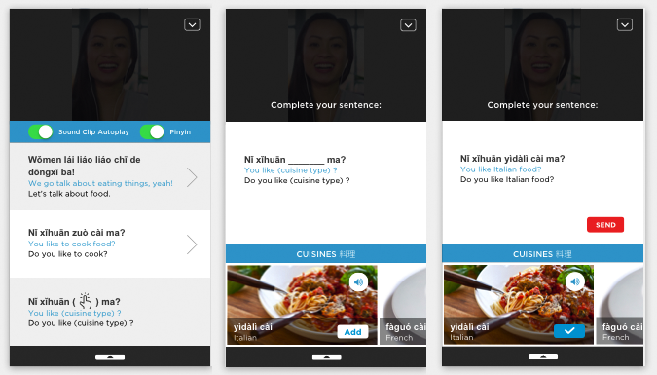

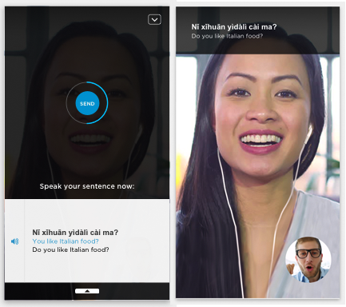

The challenge for Smart Chat is to find ways to keep users motivated and engaged. If our learners are simply repeating scripts or disconnected curriculum engagement will quickly suffer. To insure the most natural conversations possible, we use some unique coding architecture and AI, which examines user data, user behavior (through click patterns), and semantic content to provide interesting/engaging content through topic exploration and deep dives. The idea is to empower our learners to direct their own conversations and make them as close to real-life communication as possible.

With so many different types of technology available to them and a plethora of other autonomous and social activities available on their smart phones, we also make every effort to create real bonding between learners. A dating style partner search function matches learners by speaking proficiency, personal attributes, and interests.
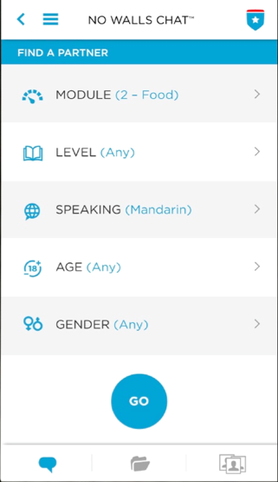
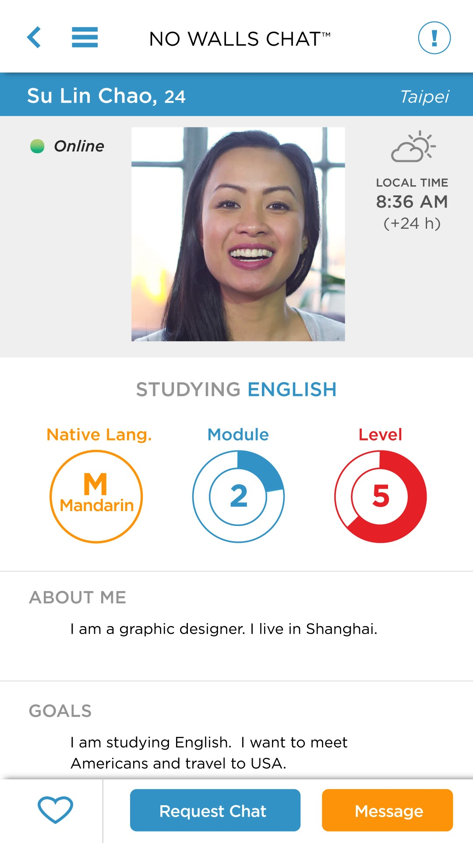

Learners take turns doing 10–minute chat sessions in their respective target languages. Short sessions help maintain focus, and create high motivation and engagement, as learners take turns helping each other with pronunciation.

We like to think Smart Chat as making a curriculum come to life, making it relevant, and facilitating real-life conversation and bonding between learners who might not otherwise have an opportunity to know each other.

Smart chat empowers schools to upload their own curriculum, combining it with our conversation-oriented modules, as they sees fit, thus making teachers and department heads stakeholders in the learning process. Smart Chat can be used either to practice conversational speaking or to focus on form through conversational means. It further allows explorations of custom topics and modules, and is able to provide multiple levels of difficulty for all content, giving learners the opportunity to encounter
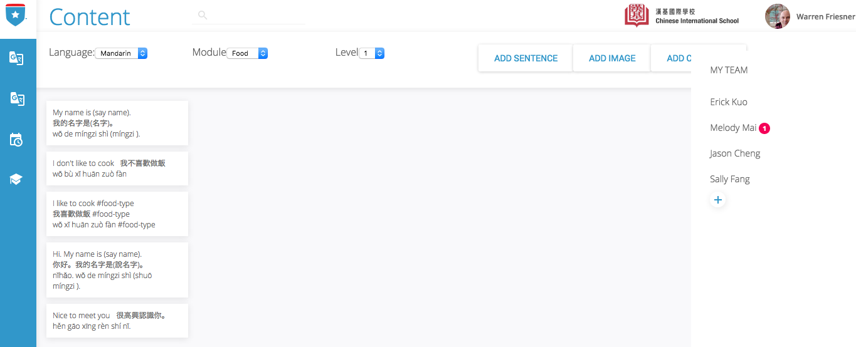

new lexical and grammatical structures, all while having a great chat.

Features and Core Loop for Smart Chat
Smart chat contains the following unique features:

- Eight levels of difficulty, providing a varied stream comprehensible content for learners of varying degrees of speaking proficiency.
- Nine modules on relevant, useful topics, such as travel, activities, food, and social chat.
- Partners can move from module to module during chat, and can also find specific topics within modules through the Explore function.
- Pinyin on or off (when off, replaced by Traditional or Simplified Chinese characters)
- Auto-play of Audio clips on or off
- Supports both video and text messaging

All Smart Chat content lives in a database. We do this for a number of reasons:

- It allows for all content to be semantically related, based on a tree structure (Parent–Child–Grandchild.), so it flows smoothly. Every response has semantic affinity to every query generating it so conversations can unfold in a logical way. (Jia, J., 2009, 66)
- It allows all content to be completely comprehensible to both learners 100% of the time, since all content is translated. This removes all production anxiety.
- It provides proper grammatical and lexical structure for all input and output.
- I allows educational institutions to upload entire curricula to the database. In essence it makes their curriculum come alive as something that can be practiced in the context of informal video chat.

Core loop:

Learner begins session in target language. Partner is native or proficient L2 speaker
Learner selects a sentence or builds it from a sentence blocks and images or word lists
Learner hears sound clip of full selected sentence
Learner is prompted to speak the sentence using L2, and may replay sound clip
Partner watches Learner as they speak sentence to help catch pronunciation errors
Partner corrects Learner’s pronunciation
Learner repeats sentence when corrected by Partner
Partner selects and speaks content using Learner L2
This process continues for 10 minutes.
After 10 minutes Partner becomes Learner and begins practice in his L2

More advanced learners may choose to use the messaging app instead of video chat:

Messaging prompts learner to enter a few words in L2 or L2 and view sentence options, Learner selects and sends message.
Partner texts back in L2, which is appears with translation for Learner

Advanced learners can dispense with all guided content and use the video app for chat.

The Digital Classroom vs. Autonomous Discovery

There’s an ongoing discussion regarding the efficacy of the LMS approach vs. a more naturalistic, exploration-based one, in which students naturally gravitate towards autonomous or group (or tandem) activities they’re most comfortable with, be they games, interactive tasks or experiences, collaborative projects, subtitled videos, or chat.

LMS are “closed-loop” curriculum publishing, tracking, performance assessment, etc. systems. They’re designed to function as extensions of the classroom, rather than places for exploration and discovery. They’re convenient for teachers, because of their predictability, built-in management tools they afford, and convergence with onsite class material. (Orsini-Jones, 2010). However, some researchers question the usefulness of LMS in terms of its restrictiveness, given typical online student behavior:

“[LMS] uniformity and predictability, however, has its disadvantages. The spoon-fed content delivery and closed environment of the LMS is far removed from the vibrant, ever-changing online world in which our students are fully engaged. Many of today’s students are likely heavy users of social networking sites, multi-player gaming, and media mashups. The static and controlled environment of an LMS is unlikely to either attract or stimulate such students. For those students less experienced in online activities, an LMS contributes little to the kind of technology literacy they will need for their personal and work lives. (Godwin-Jones, 2012, p. 6)”

In comparing LMS content delivery systems with their more autonomous, game-ifed, group-centric or chat-based cousins, it may be a good idea to look to Ellis’ guiding principles for applying best pedagogic practices:

“The opportunity to interact in the second language is central to developing second language proficiency. To create an acquisition-rich classroom, teachers need to:
- Create contexts of language use where students have a reason to attend to language
- Allow students to initiate topics and to control topic development,
- Provide opportunities for learners to use the language to express their own personal meanings,
- Help students to participate in language-related activities that are beyond their current level of proficiency, and
- offer a full range of contexts that provide opportunities for students to engage in a full performance in the language.”

(Ellis, 1999; Johnson 1995)

This discussion is important to understanding the best practices for using AI as a tool for SLA. Does AI work best when it’s delivering classroom content—for example, explicit rule modeling, practice and error correction, that adjusts to performance level, or does it function best when it stimulates engagement through games, VR, AR, chat and the like, with SLA an incidental benefit? Or, is it agnostic? One thing to remember is that AI development can be very expensive and time-consuming—training chat bots is a good example.

We believe that the key to creating a successful LMS is to ensure that each learner’s experience is NOT “removed from the vibrant, ever-changing online world”, and to empower them to contribute to and have some degree of control over the process. As we shall see, the app we’re developing seeks to combine aspects of both.

Relevant Studies
We think Smart Chat delivers content that engages and motivates users—it does so in a way that aligns with their priorities and preferences. It insures a good partner match, encourages partners to help each other, keeps each session short enough to keep each learner focused, and provides content that allows both partners to bond with and learn about each other, and explore a variety of real life topics together.

Smart Chat is unique in its reliance on user selected and spoken pre-translated content. This may be a novel method for a video app; however, some studies have found incidental acquisition in L2 while viewing L1 subtitles; e.g., Koolstra, C. & Beentjes, W. J. (1999). And as set forth above, studies show how glossed words in L2 readings, containing analogous known L2 words, or L1 words or hints contribute to processing of the L2 target word, Plonsky and Ziegler (2016).

There is also considerable body of evidence that shows that new technologies focused mainly on just speaking or listening have the ability to enhance SLA, whether synchronous or asynchronous (Payne and Whitney, 2002), (Hirotani, M. 2009).

Smart Chat vs Chat Bots
We know that real life conversation, where the user isn’t pressured to produce and where they have a genuine desire or need to know what’s being said works best; it produces the lowest affective filter. Can chat bots create the kind of affective filter necessary over the long haul to engage students so that they learn a new language?

Given what chat bots can and can’t currently do, the answer is clearly no. They’re currently a novelty able to provide a narrowly circumscribed series of responses for specific topics. That’s how Duolingo is using them. They can be programmed to act as taxi drivers and hotel clerks or restaurant managers. They may be quite useful for processing these practical tasks, even to the point of generating some acquisition.

However, bots can’t provide sustained conversation about life, marriage, aspirations, etc. Not being real people, no real bonding or friendship with them is possible, which may affect long-term motivation and engagement even as the technology improves. Without such motivation SLA is difficult. So, bots may be a great place to start the journey of learning a new language, but I have grave doubts about their ability to take anyone to the promised land.

Best AI use cases

We believe that the best use of AI for SLA, as it applies to beginning students, at least, revolves around two critical factors—a format that leverages students’ openness and interest in learning the language and maintains it over the long haul, coupled with enough comprehensible input to stimulate real proficiency, irrespective of how it’s delivered.

While the conditions for SLA are undoubtedly affected by a variety of additional variables, including age, motivation, stress, individual aptitude, types of interactions with others in the target language, and the nature and quality of the content processed, the first two conditions must always be present for successful acquisition to occur.

Understanding the differences between NLP, which is necessary for the creation of autonomous chat-bots, and the kind of “game” AI necessary to move characters around in a video game is important because we need to take a hard look at how AI can best serve SLA interests in a cost and time-effective manner.

There’s a threshold question we need to ask in terms of AI’s current and future implications for SLA. What is it capable of doing well now? What can we expect it to do well in the near and distant future? How best to harness the benefits of AI to build the best SLA paradigm immediately.

Games
The relative simplicity required for programming non-NLP AI versus the cost and difficulty involved in developing neural networks and training bots gives it a clear advantage over them, within the context of a communicative approach. On the other hand, creating visually and emotionally captivating “serious” games requires a professional design and development team—something that’s lacking in many of them.

Gaming AI can create highly interactive, engaged environments that generate an instrumental orientation to extract meaning from “mission critical” L2 messaging (to score more points, etc.). Similarly, game-ified exploration/discovery activities or AR/VR-fueled interactions have the similar advantages, while avoiding neural networks and parsing.

AI’s role in SLA within a gaming or interactive environment is reflected in the exploration, excitement, motivation and engagement it generates through its human-like responses, enhancing learners’ focus on the game’s messaging in ways they don’t in the classroom or when doing homework or reviewing online materials.

We should be thinking of new ways to better harness this ability to create much more sophisticated and complex forms of L2 interaction between game and player. Voice recognition can (and should) be built into new serious games, in which the system either responds to or prompts the learner to enter voice commands or other output at various points to open weapons caches or doors or drawers, or select red or green scarves, etc. or where “wizards” pop up at various points to ask questions. This approach avoids the huge investment in data science necessary to simply avoid errors in responding to even simple user queries.

Bots
Bot chat works well for narrowly circumscribed topics, where the system can implement a standardized protocol with a large enough corpus of relevant text to train on and negotiate meaning with users. If the subject is booking a hotel room, there’s a clear protocol and the system can accurately predict most responses. Bots are still error prone outside of their comfort zone, which consists of pattern and keyword analysis (ELIZA), tagging (allowing for responses in different categories with matching tags (ALICE), and capable of reasoning and inference, based on syntactic and semantic construction CSIEC)

Smart Chat will be the first peer-to-peer video chat to rely, partially, on bot chat technology. Because Smart Chat uses pre-translated content, rather than user-entered queries, most of the errors made by NLP-based chat bots are avoided. Most content consists of complete sentences or sentence blocks. Each sentence has multiple “parents” and “children” sentences. Affinity ratings and tagging by topic further insure a flow of conversation that makes sense both for each verbal interchange and for the longer arc of conversation, while empowering natural exploration of multiple topics.

AI (intelligent tutors) is also useful for activities that focus on form. Expert at applying rules and correcting erroneous applications of them through explicit correction, recasts, or model building, intelligent tutors can also vary exercise difficulty based on test proficiency. Perhaps it’s worth considering how such a bot can provide additional L2 input that adds communicative value to these explicit rule tasks, while correctly demonstrating the same rules.

Ethical implications of AI in SLA

It’s helpful for teaching a new language, if whatever CALL or CMC system is employed retains session data, which allows them to continually assess learners based on their prior chat or game or test history.

At the same time, retaining session data is potentially valuable as sales data. It may reveal also reveal undesirable or even criminal behavior (or tendencies in that direction) or may contain embarrassing information if publicly revealed. And, naturally, there are legal implications—does retaining the information violate the reasonable expectations of privacy? When is consent required? How may this information be used?

While a fuller exploration of this topic is beyond the scope of this paper, these will undoubtedly become important issues, given the ability of AI to build up user profiles, and the amount of personal data, including speech and messaging, that may be retained.

Just as a brief example—imagine that a murder occurs inside a house that has Echo. Can the Echo be seized and its contents scrutinized absent any probable cause that the murderer even uttered a word. What if the homeowner is suspected of committing the murder? Are all of his or her prior conversations with Echo subject to search? As the capabilities of AI become increasingly human-like, these issues will present themselves more frequently and compellingly.

References

Abdul-Kader, S., Woods, J., (2015 ) Survey on Chatbot Design Techniques in Speech Conversation Systems (IJACSA) International Journal of Advanced Computer Science and Applications, 6 (7)

Abraham, L. B. (2008). Computer-mediated glosses in second language reading comprehension and vocabulary learning: A meta-analysis. Computer Assisted Language Learning, 21(3), 199–226.

Blake, R. (2016). Technology and the four skills. Language Learning & Technology, 20 (2), 129-142.

Birulés-Muntané J, Soto-Faraco S (2016) Watching Subtitled Films Can Help Learning Foreign Languages. PLoS ONE 11(6): e0158409. https://doi.org/10.1371/journal.pone.0158409.

Burston, J. (2015). Twenty years of MALL project implementation: A meta
-analysis of learning outcomes. ReCALL, 27(1), 4–20.

Dulay, H. and Burt, M. (1974) Natural sequences in child second language acquisition.
Language Learning 24: 37-53.

D'Ydewalle, G., & Van de Poel, M. (1999). Incidental foreign‒language acquisition by children watching subtitled television programs. Journal of Psycholinguistic Research, 28, 227‒244

Ellis, R. (2005). Instructed Second Language Acquisition: A Literature Review. Wellington: Ministry of Education.

Godwin-Jones, R. (2014). Emerging Technologies—Games in Language Learning: Opportunities and Challenges. Language Learning & Technology, Volume 18, Number 2.

Heift, T. (ed.) (2009). Technology and Learning Grammar. Special Issue in Language Learning and Technology, 13(1), 120 p.

Hirotani, M., (2009). Synchronous Versus Asynchronous CMC and Transfer to Japanese Oral Performance, CALICO Journal, 26(2), 413-438.

Hubbard, P. (Ed.) (2009). Computer Assisted Language Learning: 1 (Critical Concepts inLinguistics). London: Routledge.

Hubbard, P., 2008. CALL and the future of language teacher education. Calico Journal. 25 (2), 175-188.

Jia, J., (2009) An AI Framework to Teach English as a Foreign Language: CSIEC. AI Magazine, Summer 2009, 59–71.

Koolstra, C. & Beentjes, W. J. (1999). Children’s vocabulary acquisition in a foreign language through watching subtitled television programmes at home. Educational Technology Research & Development 47, 51-60.

KRASHEN, S. (1981) Second Language Acquisition and Second Language Learning. Oxford: Pergamon Press.

KRASHEN, S. (1982) Principles and practice in second language acquisition. S Krashen. Oxford

Nagata, N. (1993). Intelligent computer feedback for second language instruction.
Modern Language Journal. 77(3), 331–339.

Payne, J. S. and Whitney, P. J. (2002) ‘Developing L2 oral proficiency through synchronous CMC: output, working memory, and interlanguage development’, CALICO Journal, 20(1): 7–32.

Persis Dineen Rodrigues, Malachi Edwin Vethamani, The Impact of Online Learning in the Development of Speaking Skills, Journal of Interdisciplinary Research in Education, 5, (1), 2015.

Phillips, W. (2006) Introduction to Natural Language Processing. Consortium on Cognitive Science Instruction, http://www.mind.ilstu.edu/curriculum/protothinker/natural_language_processing.php?modGUI=194&compGUI=1970&itemGUI=3445 .

Plonsky, L., Ziegler, N. (2016). The CALL–SLA Interface: Insights From A Second Order Synthesis. Language Learning & Technology, 20, (2), 17–37.

Reinders, H. (Ed.) (2012). Digital games in language learning and teaching. New York: Palgrave Macmillan, 95-114. [ Links ].
Suh, SW Kim, NJ Kim (2010) - Journal of computer assisted learning, 26 (5), 370–378
Swain, M. (1995). Three functions of ouput in second language learning. In G. Cook & B. Seidhofer (Eds.), For H. G. Widdowson: Principles and practice in the study of language. Oxford: Oxford University Press.

Sydorenko, T. (2010). Modality of input and vocabulary acquisition. Language Learning & Technology, 14(2), 50–73. Retrieved from http://llt.msu.edu/vol14num2/sydorenko.pdf.

Taylor, A. M. (2009). CALL-based versus Paper-based Glosses: Is there a difference in reading comprehension? CALICO Journal, 27, 147-160.

Johnson,W., Vilhjalmsson, H., Marsella, S., (2009). Serious Games for Language Learning:
How Much Game, How Much AI? Center for Advanced Research in Technology for Education USC / Information Sciences Institute.

J. Weizenbaum (1966) “ELIZA: A computer program for the study of natural language communication between man and machine,” Communication of the ACM, 9, (1), 35-36.

Yudintseva, A.(2015) Game-Enhanced Second Language Vocabulary Acquisition Strategies: A Systematic Review. Open Journal of Social Sciences, 3, 101-109.
http://dx.doi.org/10.4236/jss.2015.310015

Yoshii, M. (2006). L1 and L2 glosses: Their effects on incidental vocabulary learning. Language Learning & Technology, 10(3), 85–101. Retrieved from http://llt.msu.edu/vol10num3/yoshii/.

Yun, J. (2011). The effects of hypertext glosses on L2 vocabulary acquisition: A meta-analysis. Computer Assisted Language.

